building a smart workforce

Discovery Sessions

The Smart Working Revolution
Phone 07976 509551
Email ideas@smartworkingrevolution.com
Website www.smartworkingrevolution.com

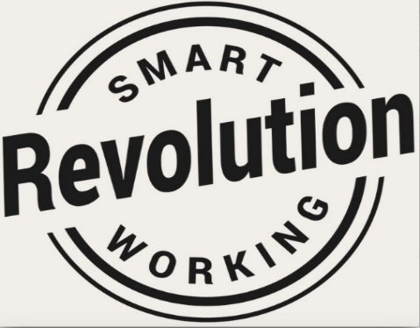

Smart Workforce & Leadership
Discovery Sessions
Technology is encouraging employers like you to invest in an smart workforce model. But it’s not just about the tech - when you transform the way your business works, you must also transform your workforce.
We have 20 Years of experience in delivering these benefits to Organisations similar to yours and we recognise the questions and uncertainty the subject of non-office based roles raises for businesses. This is why, over the years, we have developed powerful strategies that open mindsets toward adoption of flexible working.
We offer 5 half day Discovery Sessions
- Smart Workforce Model
We introduce your team a to the 50 options in the Smart Workforce Model and help you determine which would work in your business and which to avoid. At the end of the session you will leave with 3 possible options to pilot.

- Smart Individuals
The Smart Workforce will only work when all team members accept, support and adopt the smart workforce vision. Obviously, to be successful they will need to learn new skills, practices and new ways of operating.

- Smart Teams
Teams will receive development in how to work as a distributed team member. It’s important to set expectations, agree guidelines and maximise performance so that Team members quickly become acclimatised to new work practices and, as a result, trust builds quickly.

- Smart Leaders

Leaders who understand the vision of a Smart Workforce, get behind it and set transformation goals for success. They require a different set of skills to those who manage traditional office based teams. Smart Leaders create a clear line of sight between the performance of the individual and the achievement of business outcomes - and they do that from afar - it's a real art. Training Leaders is the most important investment you will make.

- Smart Business Wisdom
When individuals, teams, leaders, departments share a common vision, they become better connected, collaborate freely across boundaries, share their knowledge so that the whole business is continuously learning. That’s when the magic happens. In this discovery session you’ll develop and action plan to build the infrastructure you need to achieve this.

These half day workshops are normally priced at £1500 each but for a limited period are available to East Midlands Chamber Members at a cost of £749 for up to 10 people.

To book a discovery session of your choice contact ideas@smartworkingrevolution.com

Read about the benefits of Smart Working overleaf
Benefits

When effectively deployed, smart working brings many benefits:

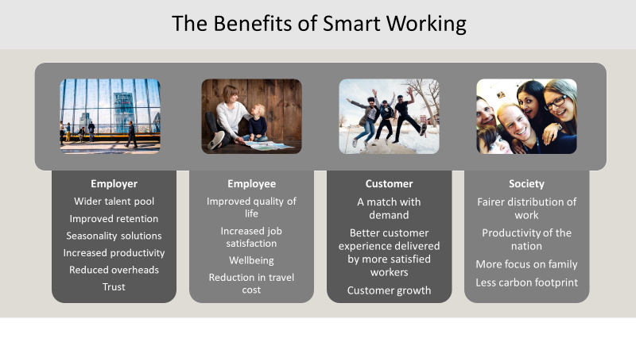
Over the last 20 years we have learned from our mistakes so that you don’t have to. We understand the pitfalls of implementing smart working and will guide you safely to success at pace.
We look forward to an exciting partnership with you.
Don’t just take our word for it.

I’m pleased we chose to work with The Smart Working Revolution. From the initial consultation all the way through the project’s conclusion, the service I received was impeccable. The end result helped our business massively.
Rob Love. CEO. Crowdfunder

The feasibility and pilot that we did with the Smart Working Practitioners was successful on a number of fronts. The team found whole process both stimulating and enjoyable – very timely. We’ve implemented some great organisational improvements.
Anna Todd. Sales Director. Which Legal

The Experts from the Smart Working Revolution will guide you through every step of the design of the workforce model. With their help, we managed to put our plans and savings in place at pace. We now have 200 smart workers and we continue to refine our strategy to meet emerging business needs, thanks to the SWR Team.
Simon Smith. Head of HR. Saga

‘SWR proved a real asset in helping the organisation build momentum towards smarter working. They are highly experienced, very knowledgeable and professional in their approach.’
Kevin Brewin. Head of OD Charnwood BC

‘For us as a company and especially the senior leadership team, flexible working is at the forefront of our minds and our values, The Smart Working Programme gave us the tools to select which options would work for us short and long term. We have been able, for the first time, to come up with a pilot scheme which has gained board approval. I would recommend any company that is thinking of hiring the SWR team to do it without question’.
Sam White. CEO. Freedom Insurance Group

Connect with us here
Visit our website www.smartworkingrevoution.com
Connect with us on Linkedin for regular updates https://www.linkedin.com/in/ruthgawthorpe/?msgConversationId=6620955633963290624&msgOverlay=true
Sign up for our newsletter https://smartworkingrevolution.com/newsletter-2/

