smart workforce

model

Feasibility Workshop and
Pilot Support

The Smart Working Revolution
Phone 07976 509551
Email ideas@smartworkingrevolution.com
Website www.smartworkingrevolution.com

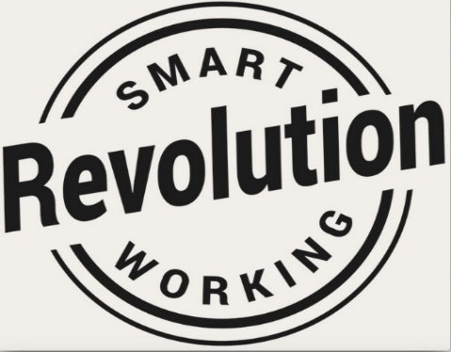

Smart Working Implementation
Feasibility Workshop

We are a team of practitioners who have been implementing smart working options for 2 decades and we’ve designed all manner of smart solutions to address business challenges.
Did you know, we have a suite of more than 50 options that Leaders can choose from in our Smart Workforce Model? In our Feasibility Workshop, your Team will unleash which of those 50 options match the needs of your customer demand, so that your business is ready to test them.
Our Feasibility Workshops are perfect for Business Teams, including HR, who want to unlock the full range of options available in a Smart Workforce Model in order to build a business case for senior leadership.
In our one day workshop we help your Team sort out which options will work for you and which will not. You leave with 3 possibilities to pilot and a rounded understanding of the impact to your business.
Pilot Support
We support your team through the pilot process, which is a preliminary test of your maximum of 3 smart working options. Piloting the news ways of working are an necessity as they lower the risk of failure.

Implementing a smart workforce is not as easy as some people think and this is an opportunity to trial a small scale, measured, reversible test that will gain buy-in from your people.

We’ll coach your Leaders through a structured approach and plan, in bi-weekly coaching sessions to get the pilot off the ground over a 6 to 8 weeks period. This will enable you to reach optimum performance so that you can make the decision to move forward to implementation.

Price from £4779 plus VAT and expenses
Learn more about how we can help your business work smarter. Contact us

