Smart working discovery workshop and Policy package

50 different options

The Smart Working

Revolution
Phone 07976 509551
Email ideas@smartworkingrevolution.com
Website www.smartworkingrevolution.com

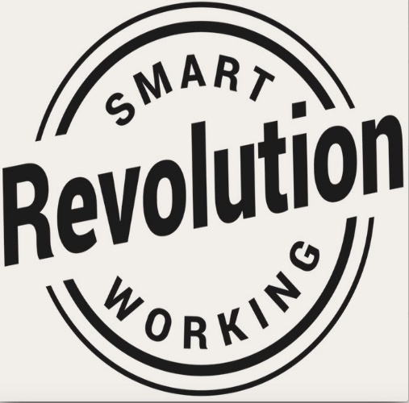

Introducing Smart Working
There are 50 different smart working options to choose from in our Smart Workforce Model.

Discovery Workshop
Successful smart working is built on trust and empowering employees to be productive wherever they are working. This award-winning Workshop is the first step in helping Leaders of the future to understand just how different and rewarding it is to manage people who are not in the same office. Leaders realise the advantage of building 2-way trust that helps develop a team - and a business, with a growth mindset.
Our Workshops are perfect for a Business Team who want to unlock the full range of benefits available in a Smart Workforce Model in order to build a compelling case for senior leadership and stakeholders
We have a tried and tested methodology that we take your team through to enable them to unleash which of those 50 options match your customer demand and which to avoid. We factor in those ways of working that you are already using too.
Crucially, we focus on service demand and which choices will enable better customer experience. These lead to some fabulous new options for your people. Win/Win!
You and your team will leave with a pilot plan, a rounded understanding of the impact to your business and the way that the culture should evolve as well as an understanding of the savings and benefits to the business, the employee, the customer, and your community.
It is a no-nonsense, immersive and action-packed workout full of practical takeaways that our panel of practitioners have refined over 20 years of successful smart working implementation

Policy Template
A one-day workshop or one day of consultancy following the Discovery Session to help your HR Team build a Can-Do Smart Working Policy or set of guidelines.
You will need to clearly outline what it means for employees to work smart in detail, and a smart working policy is a great place to begin. You’ll want this in your toolkit if you are to build and embed a smart culture.
But example Policies are not easy to come by - that's why we've built a template package using our extensive HR and operational experience of implementing smart and agile workforces. We will cover the various options and helps you negotiate pitfalls. We guide you in how to create a policy that builds a smart culture that attracts & retains the best people.
Pilot Support
We have found that Managers require support and advice while they are piloting smart working and so we offer a service which is tailored to meet the needs of their busy schedules. We coach Leaders through their bespoke pilot, including engagement of the team, how to create smart working agreements with each individual, measure the pilot’s success and tweak elements to ensure optimum productivity. This ensures the pilot is ready to move to successful smart working implementation.
This package covers:
- A one-day Discovery Session for your Team of 10 to help them understand the ins and outs of smart working including how to avoid the pitfalls.
- Access to our Policy Template and a workshop for your team or professional support with developing your bespoke Policy
- Pilot support for Managers
- 2 virtual coaching and advice sessions following the workshop

Prices for your team begin att:
- £2477 for the Discovery Workshop. (Including our unique Workforce Model)
- £1577 for the Smart Working Policy Template, HR Workshop or Consultancy
- £900 per day for Pilot Support
As a package we reduce the cost of 1 & 2 to £3477 plus £750 per day for pilot support, plus, VAT and expenses at cost. The more Discovery Workshops that you book, the more reasonable the price. Just ask!
This represents very good value as it includes all pre-work, design, survey, 2 coaching sessions and post work feedback.
Learn more about how we can help your business work smarter. ruth@smartworkingrevolution.com
Don’t just take our word for it
I’m pleased we chose to work with The Smart Working Revolution. From the initial consultation all the way through the project’s conclusion, the service I received was impeccable. The end result helped our business massively.
Rob Love. CEO. Crowdfunder
The work that we did with the Smart Working Practitioners was thought provoking on a number of fronts. The team found it both stimulating and enjoyable – very timely. We’ve implemented some great improvements.
Anna Todd. Sales Director. Which Legal
The Experts from the Smart Working Revolution will guide you through every step of the design of the workforce model. With their help, we managed to put our plans and savings in place at pace. We now have 200 smart workers.
Gary Duggan. CEO. Saga
‘SWR proved a real asset in helping the organisation build momentum towards smarter working. They are highly experienced, very knowledgeable and professional in their approach.’
Kevin Brewin. Head of OD Charnwood BC
‘For us as a company and especially the senior leadership team, flexible working is at the forefront of our minds and our values, The Smart Working Programme gave us the tools to select which options would work for us short and long term. We have been able, for the first time, to come up with a pilot scheme which has gained board approval. I would recommend any company that is thinking of hiring the SWR team to do it without question’.
Sam White. CEO. Freedom Insurance Group

