FUTURE CAREERS | - Smart working revolution
Outplacement can be emotional….  Redundancy is a word that people fear. It can be a challenging and emotive time for the organisation and for those individuals who are affected.  That’s why we help you support individuals at all levels across all sectors by providing bespoke, cost-effective outplacement, redeployment, career change and pre-retirement programmes.  We are experts in our field and our Practitioners each have 20+ years’ experience in the HR sector.  Our range of services include both face to face/virtual coaching but also online resources that enable 24/7 inclusive support for employees who are leaving your organisation. These include but are not limited to:  - Executive Leadership  - Middle Management  - Technical Experts  - Contact Centre and Customer Service workers  - Over 50s | Outplacement Toolkit  Contact Info  07976 50955 Ideas@smartworkingrevolution.com  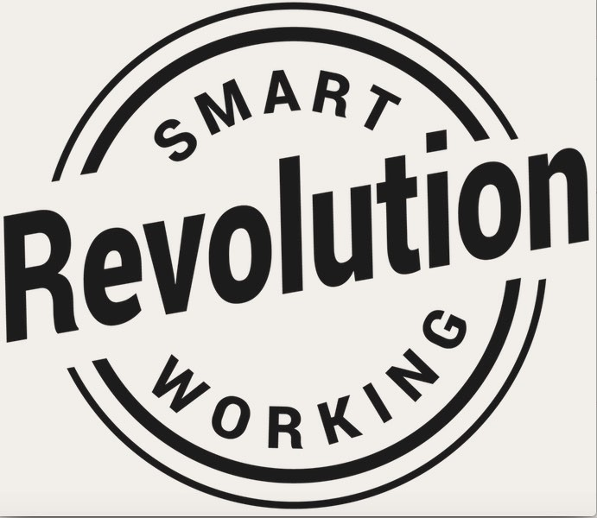
Outplacement Toolkit  So, what does a personal action plan look like?  .  We are trained in Harrison Assessments which provides the employee with awareness and clarity around their career specific behavioural fit, emotional intelligence and competencies. We can support them with dealing with life change, help them consider options and plan their next career move effectively.  We introduce participants to the importance of personal brand marketing which gives them the edge in a busy labour market.  We are career coaching practitioners, so our support is 'hands-on', helping the participant to write a winning CV or amending it to optimise impact. We help them to prepare for interviews, advise on job hunting, LinkedIn and the hidden jobs market,  Get in Touch to set up your outplacement and we’ll take the weight off your shoulders.  Email ideas@smartworkingrevolution.com | A New Career  Contact Info  07976 50955 Ideas@smartworkingrevolution.com

