Champions of change | - Smart working revolution
Imagine…..  What would happen if you got everyone in your organisation moving in the same direction?  To unlock change and growth, leaders need to consider not only what they believe they can achieve….but also what their team believe they can achieve too!  But the truth is - lack of clarity and intent is a problem for business change and it’s more common than you might think. In the very same company Leaders often have differing views of the intent and priorities.  This is not just about embracing a vision of change. It’s about understanding the point of it and supporting each other in a way that allows every individual on your team to take active ownership of the plan.  Remember the story about JFK asking the janitor at Nasa what his job was? His response was ‘to put a man on the moon’. In that story, everyone understood the vision at every level. So, how do we get there? Read on…. | Change Management Toolkit  Contact Info  07976 50955 info@smartworkingrevolution.com  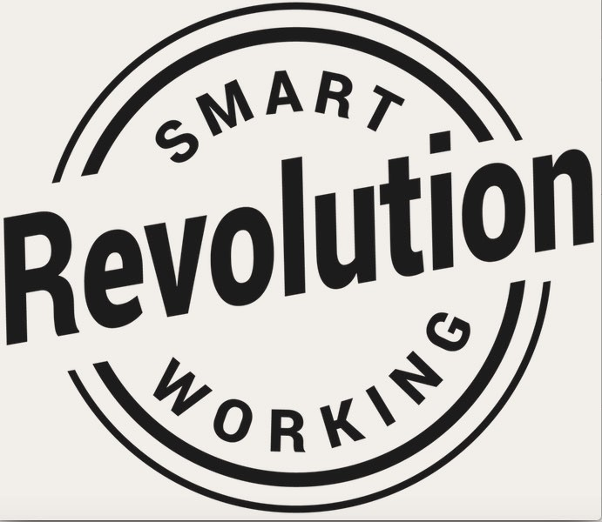
Toolkit  We share insights into change management and explore the approaches, models and techniques that will make your team think and your transformation successful.  We also investigate the possible pitfalls that Change Champions face as they drive organisational transformation so that your team can navigate around them.  Our Action Orientated Programme includes:  - Different Types of Change  - The Importance of Shared Vision  - Organisational and Individual Barriers to Change  - The Five Steps of Effective Change  - Decision Making during Change  - Change and Communication  We’ll share case studies that bring change to life and show your Champions how they can implement a plan where everyone feels involved, secure, confident and most of all, receptive so that your business achieves the benefits of effective change.  Prices from just £3k plus VAT for 10 delegates  Get in Touch to set up your first session to equip your team to become Champions of Change | Change Management Toolkit  Contact Info  07976 50955 Ideas@smartworkingrevolution.com

